Redesign of Berlin Government

Appointment Website
Project Title: Redesign of Berlin.de / Service Portal Berlin (City Registration)
Platform: Desktop
System: Berlin.de / Service Portal Berlin
Location Encountered: Personal use while searching for city registration (Anmeldung) information and booking an appointment.

Design Flaw
The design flaw is observed through screenshots of the current Berlin.de and Service Portal Berlin website.

Observed issues from screenshots:
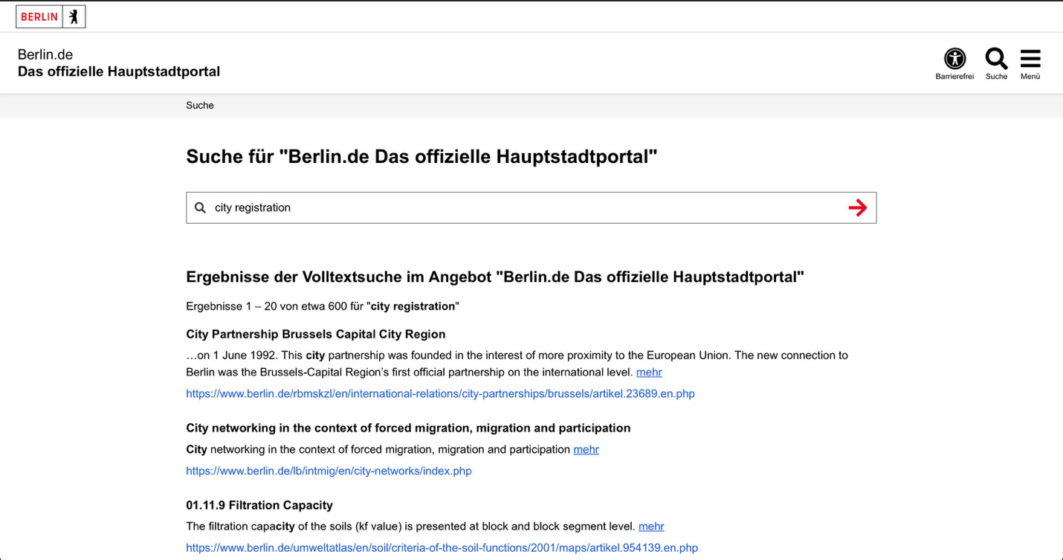Fig1: Searching for “city registration” shows unrelated results (city partnerships, soil data).
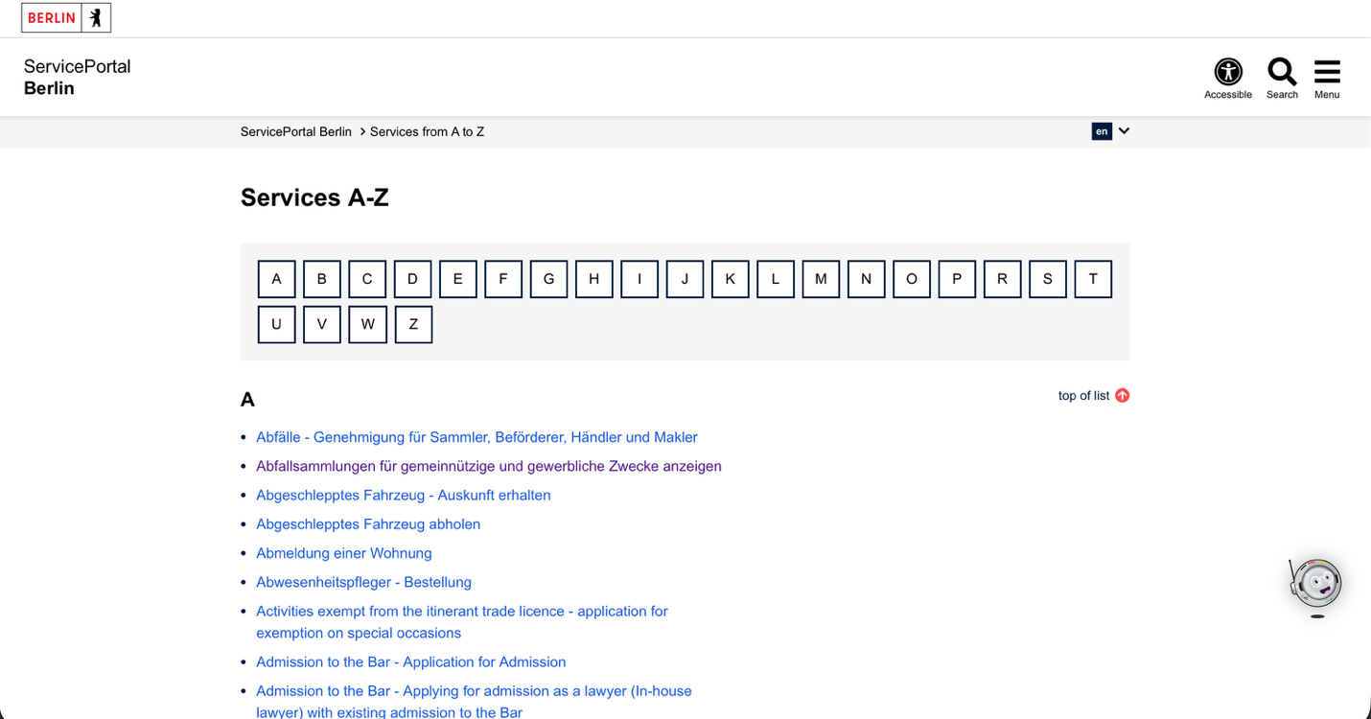
Fig2: The actual registration service is buried among long lists.
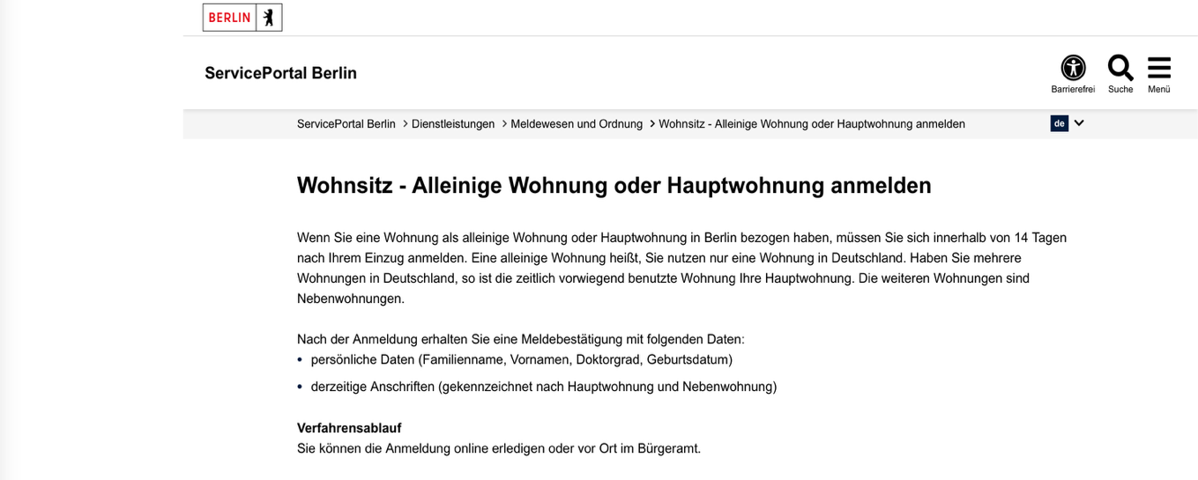Fig3: Multiple information instead of guiding the user forward.
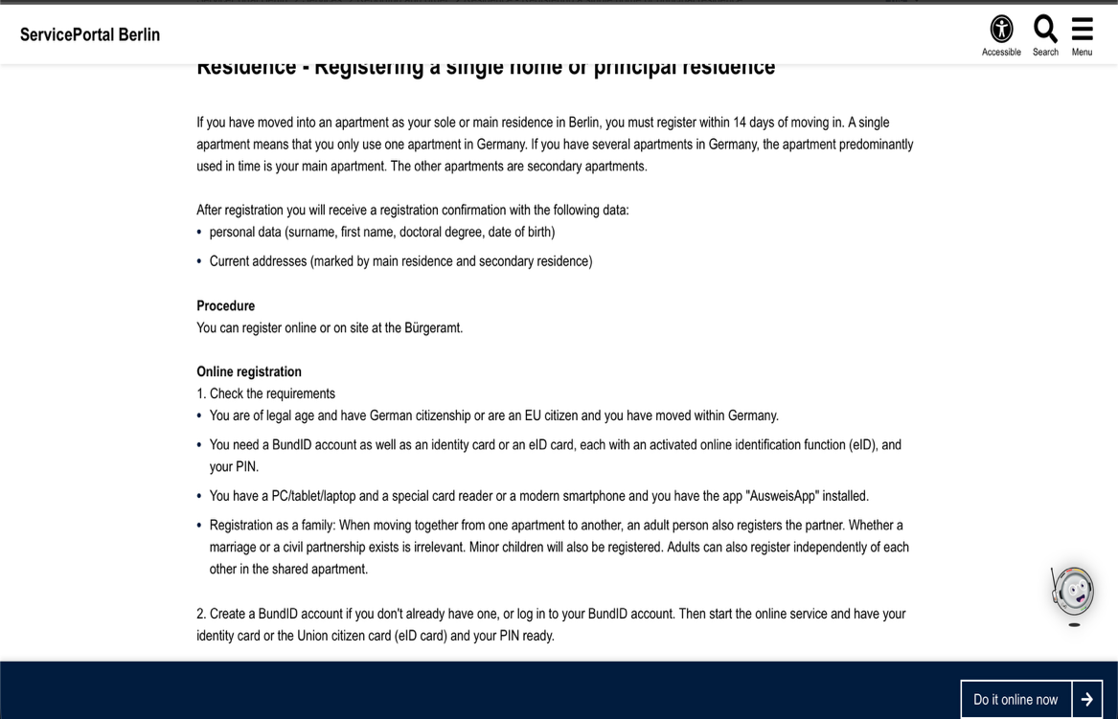
Fig4: The “Do it online now” button appears which confuses user.
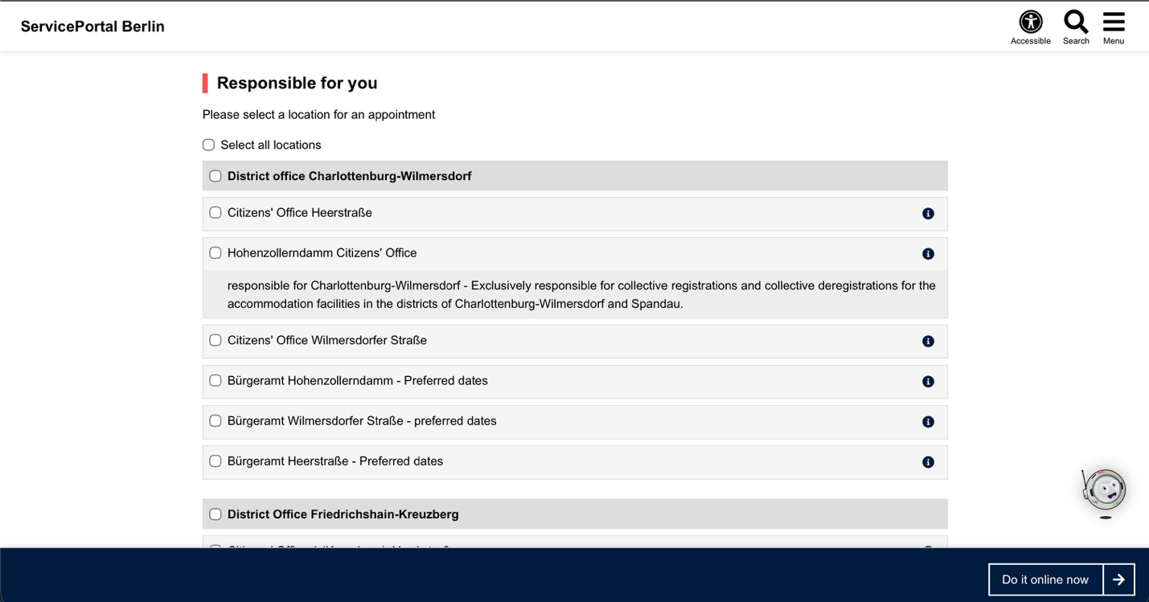
Fig5:Appointment selection for offline is very late user has to scroll down to see this.
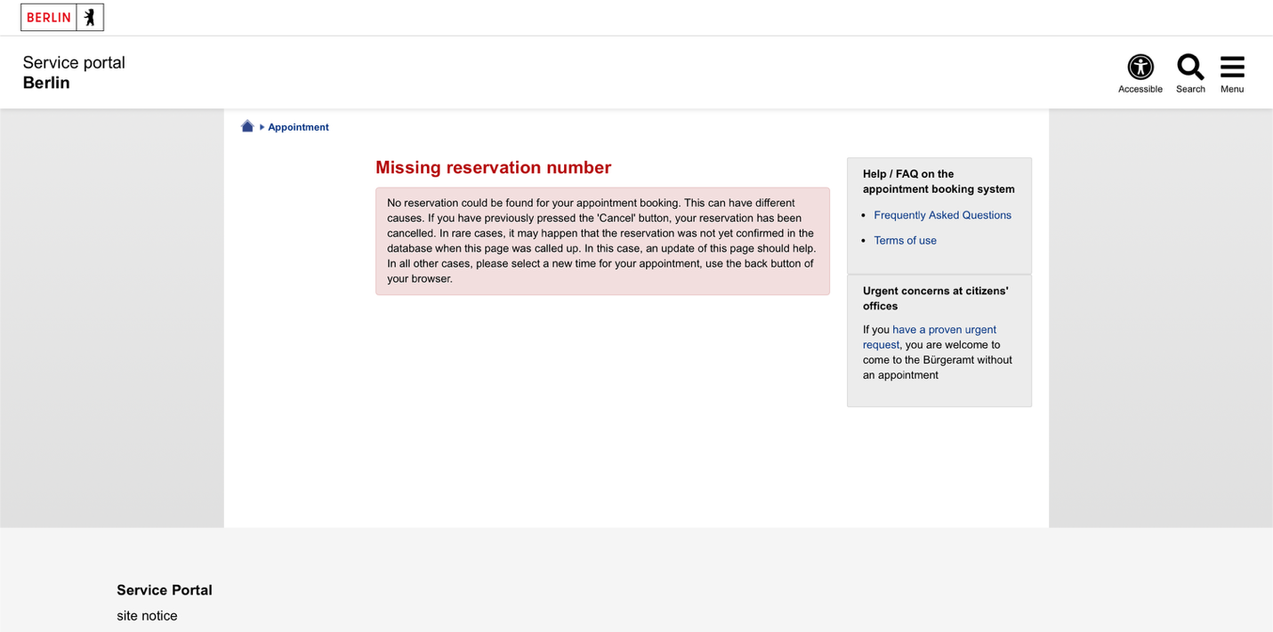
Fig6: Poor feedback and no recovery guidance
These screenshots clearly show real user confusion, not a hypothetical problem.

Why This Is a GUI Problem (Not UX, Not Hardware)
The interface shows too much information at once but does not clearly show what the user should do next.
It should show a clear step-by-step path for registration, but instead presents long text and unrelated options.
This mismatch causes user errors because the visual structure does not match the system logic.

Scenario Illustrating the Flaw
A user moves to Berlin and searches “city registration” on Berlin.de.
The search results show many unrelated links, so the user clicks randomly.
After reaching the registration page, the user scrolls through long text and is unsure whether to register online or book an appointment.
When selecting an office, the user sees a very long list without guidance and does not know which office applies to them.
The system does not confirm progress or guide the next step.

The Core Task the Interface Should Support
Primary task:
Register a new residence in Berlin (Anmeldung) successfully.

Analysis of Why the Interface Fails

Structure
- Important actions (online registration, appointment booking) are not shown first.
- Long text blocks appear before clear actions.
- Office lists are too long and not grouped by relevance or location.

Semantics
- Search results do not match user intent.
- Buttons like “Do it online now” appear without explaining consequences.
- Icons and headings do not clearly communicate progress or status.

Feedback
- The system does not confirm where the user is in the process.
- No clear indication of “Step 1 / Step 2 / Step 3”.
- After selecting options, the interface does not reassure the user they are on the right path.

Redesign Concept Overview
The redesigned interface restructures the Anmeldung process into a clear step-by-step flow.
The first screen clearly asks what the user wants to do: Register online or Book an appointment.
Information is grouped into short sections with clear labels and consistent meanings.
Each user action triggers visible feedback showing progress and next steps.
The redesign focuses on communication, not decoration.

First Screen Sketch:
The first screen includes: 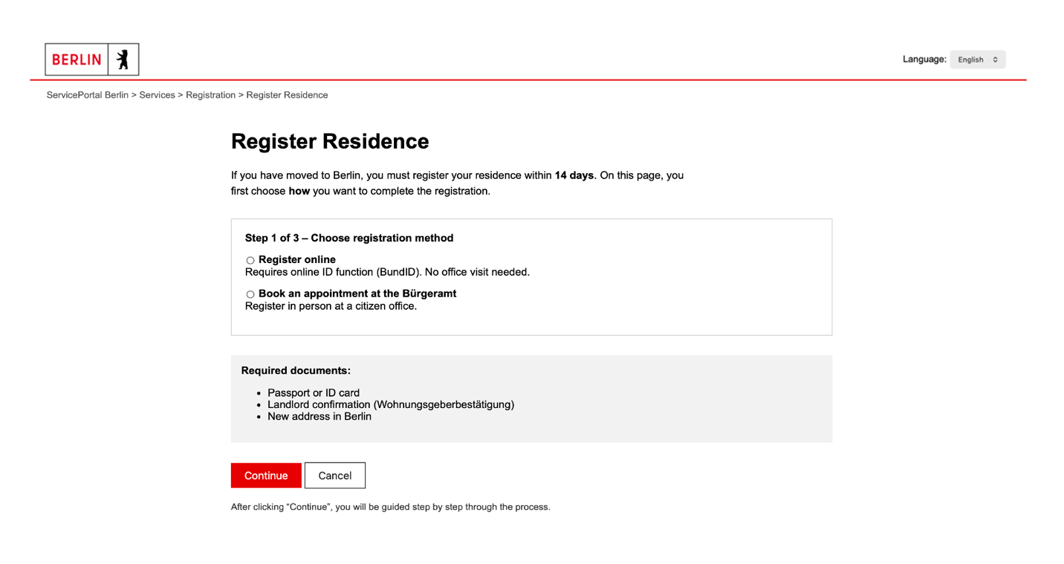
- Main Content: Two clear options:
  - Register online
  - Book an appointment
- Action Buttons: Large, clearly labeled buttons
- Feedback Area: Text showing what will happen after selecting an option

Screens for Final Prototype

Screen 1: Select a Bürgeramt
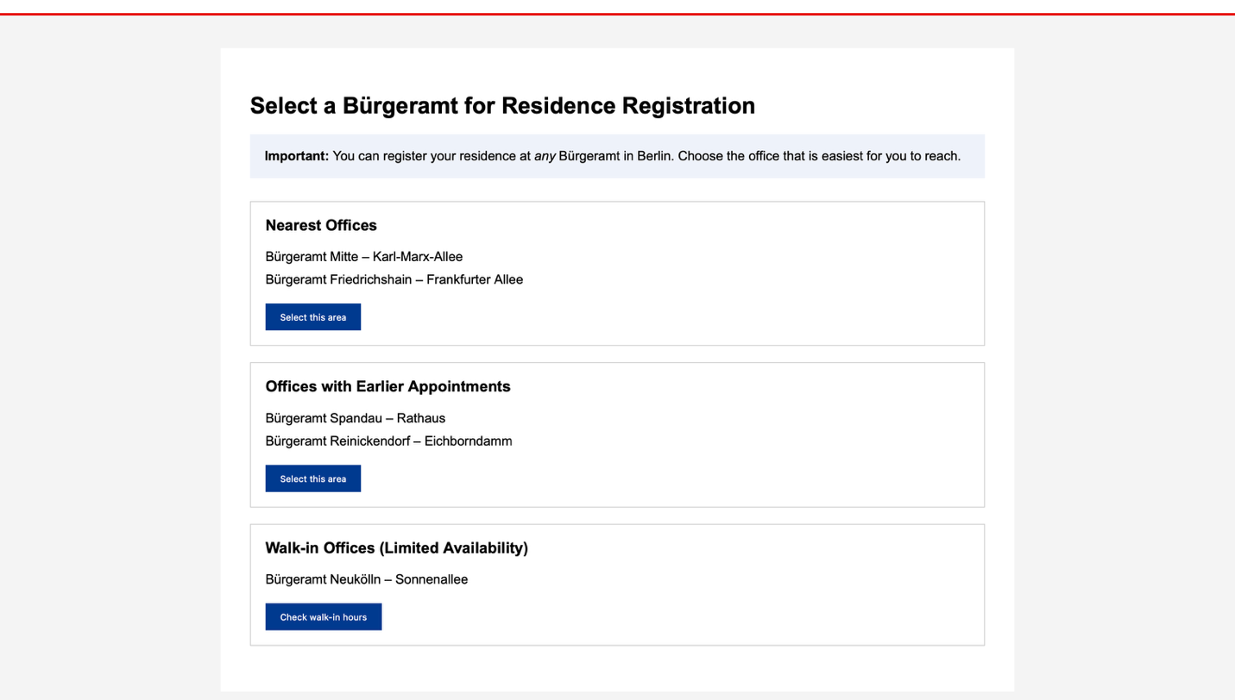
What this screen includes:
- A clear title explaining the task: selecting a Bürgeramt.
- An important notice explaining that any Bürgeramt in Berlin can be used.
- Offices are grouped by meaning, not one long list:
  - Nearest offices
  - Offices with earlier appointments
  - Walk-in offices (limited availability)
- Each group has a short explanation.
- Each group has one clear action button.
- No long scrolling list of unrelated offices.

Why this is better:
- Users can quickly decide which office fits their situation.
- The interface supports human decision-making.
- Clear structure replaces overwhelming lists.

Screen 2: What Happens at the Bürgeramt (Process Explanation)
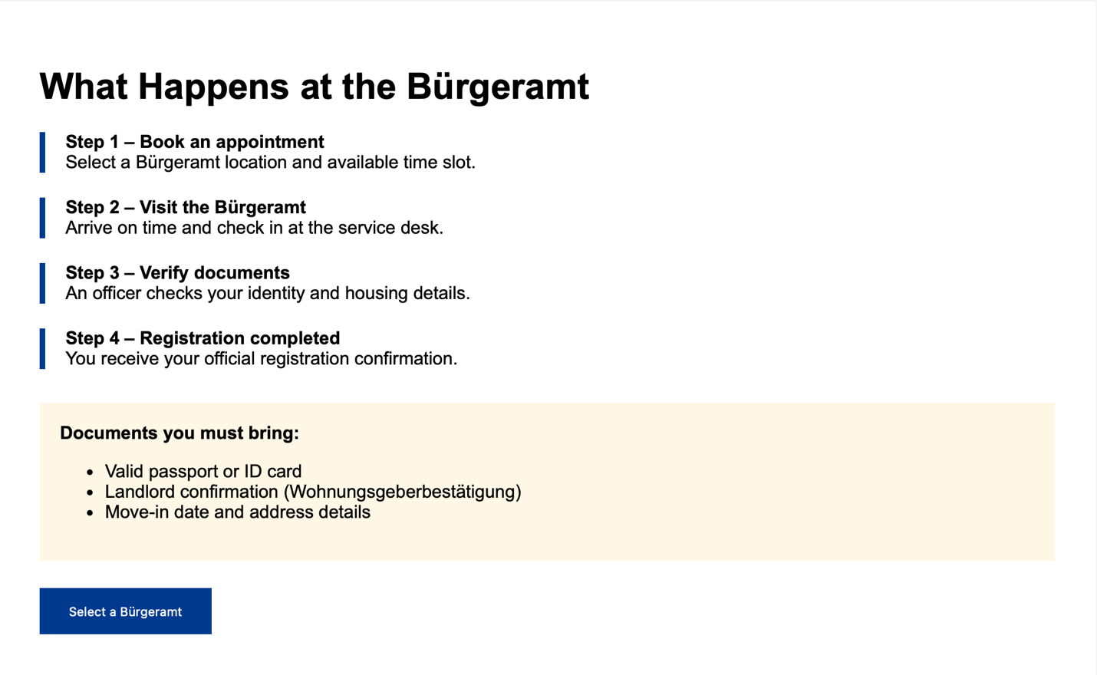
What this screen includes:
- A step-by-step explanation of the offline process.
- Each step is clearly numbered:
  - Book an appointment
  - Visit the Bürgeramt
  - Document check by staff
  - Registration completed
- A document checklist showing exactly what the user must bring.
- Information is grouped into steps and boxes, not long text paragraphs.
- A single clear action button: “Select a Bürgeramt”.
Why this is better:
- Users know what will happen before they visit.
- Reduces anxiety and confusion.
- Prevents missing documents.

Screen 3: Appointment Not Found (Error Screen)
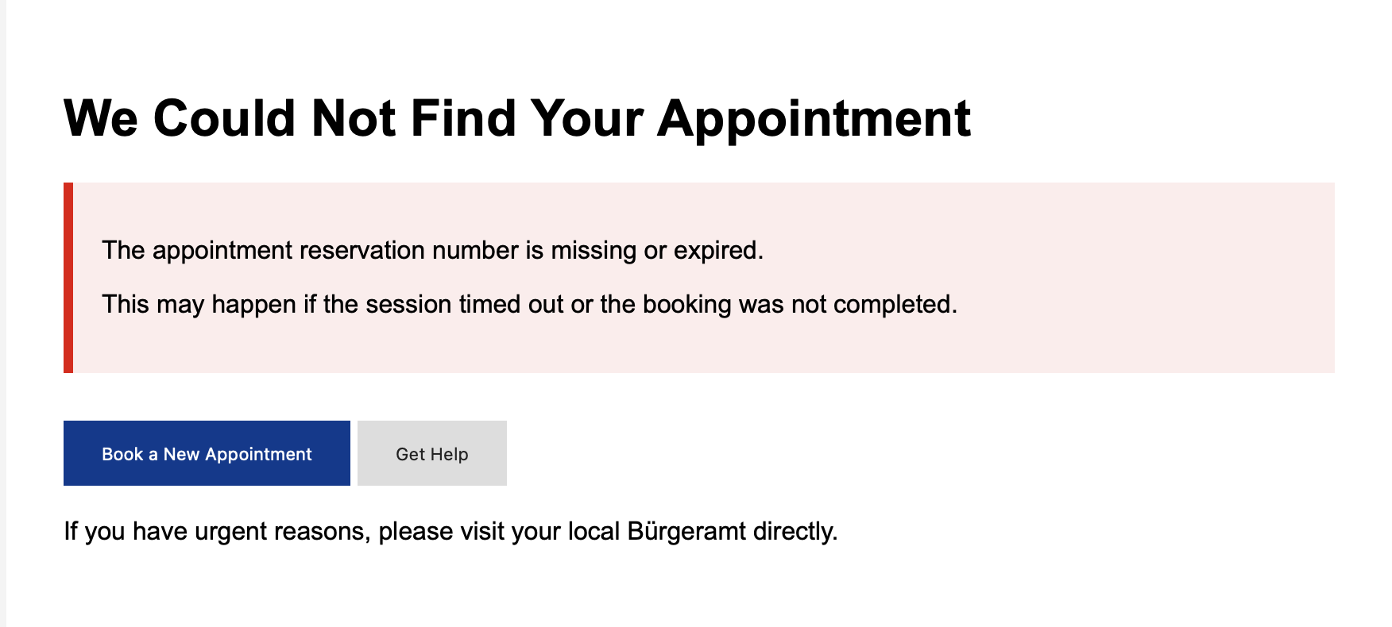
What this screen includes:
- A clear headline stating the problem: “We Could Not Find Your Appointment”.
- A short explanation of why this happened (missing or expired reservation number).
- The reason is explained in plain language, not technical terms.
- Two clear action buttons:
  - “Book a New Appointment”
  - “Get Help”
- A clear offline option, telling users they can visit the Bürgeramt directly for urgent cases.
- Error message is visually highlighted so users do not miss it.
Why this is better:
- The user immediately understands what went wrong.
- The system clearly tells the user what to do next.
- No guessing or dead end.

Expected Design Challenges
- Reducing information overload while keeping legal requirements visible
- Making complex government rules understandable without oversimplifying
- Keeping feedback clear without interrupting user flow

